ENVIRONMENT SETUP

CREATE A FLASK PROJECT

TEAM ID | PNT2022TMID34668
PPROJECT NAME | NUTRITION ASSISTANT APPLICATION

CODE:

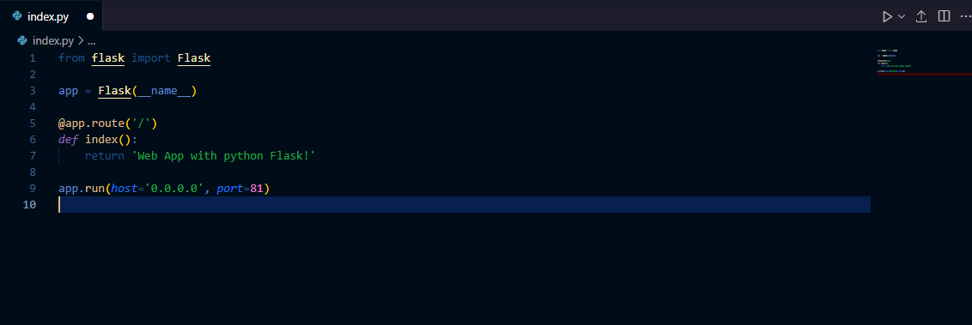

TERMINAL:

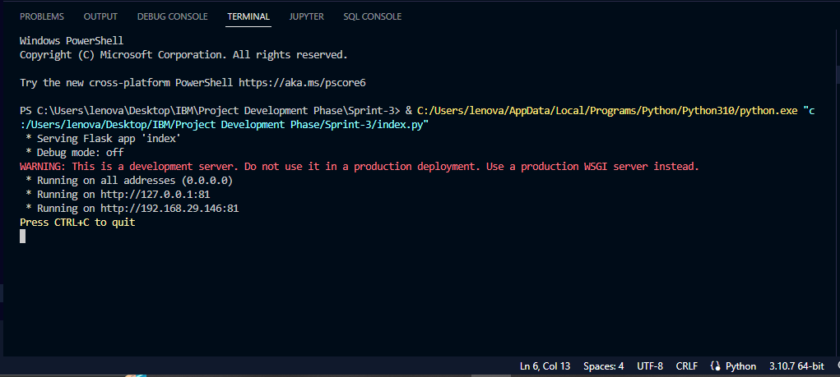
OUTPUT:

